To play a in an Exhibition game or ALLIANCE Hockey Tournament, teams must receive approval from their Operating Committee Representative or Association Delegate. Important Note: ALLIANCE TEAMS must receive approval from their Home Association. Each Association has the responsibility to ensure that participation is against Hockey Canada sanctioned teams. Participation against non-Hockey Canada and International Ice Hockey Federation sanctioned teams or unapproved travel may result in the forfeiture of Hockey Canada Insurance coverage and discipline to the respective team official(s).

Competition: Your Team Information:

PARTICIPATING IN: |  |  | TEAM DIVISION: |  |  | TEAM CATEGORY:
Exhibition Game |  |  | Tyke |  |  | AAA
Tournament Game |  |  | Pre-Novice |  |  | AA
 |  |  | Novice |  |  | A
BRANCH COMPETITION: |  |  | Minor Atom |  |  | MD
ALLIANCE |  |  | Atom |  |  | Select
GTHL |  |  | Minor Peewee |  |  | House
NOHA |  |  | Peewee |  |  | BODY CHECKING:
OMHA |  |  | Minor Bantam |  |  | Yes
ODHA |  |  | Bantam |  |  | No
USA |  |  | Minor Midget |  |  | OFFICIALS:
OTHER |  |  | Midget |  |  | Refs
 |  |  | Juvenile |  |  | Timer

Competition Information (Exhibition ALLIANCE Hockey Tournament):
Tournament or Team Name:
Contact Name & Position:
Phone or Email:
Tournament Sanction #
Exhibition Date & Location

Team Official Information (person completing form):
Team Name:
Contact Name & Position:
Phone:
Email & Fax:
Date Initiated:

ALLIANCE Hockey – Operating Representative / Association Approval
Name:
Signature:
Date:
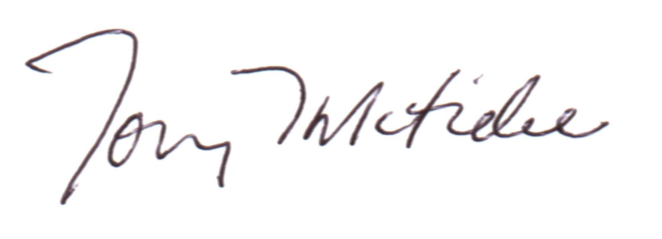

ALLIANCE APPROVAL

Executive Director

LOCAL ASSOCIATION USE ONLY
PAYMENT REQUIRED:
AMOUNT:
PAID:

